benefit_amount feature in the reimbursements table represents the dollar value of the reimbursement payment to the victim of EBT theft. benefit_amount analysis provides crucial insights into the value of theft claims and reimbursements.
Value of Reimbursements:
Calculate the total value of reimbursements reported before and after the policy change. Sum the benefit_amount for transactions before and after the policy change to observe the overall impact of the policy change on the monetary value of theft reimbursements.
Average Value of Reimbursements:
Analyze the average value of reimbursements by dividing the total benefit_amount by the number of reimbursements. This analysis helps identify if the policy change affected not only the volume but also the size of theft reimbursements.
Distribution of Reimbursement Values:
Analyze the distribution of reimbursement values by plotting a histogram of the benefit_amount. Visualize the histogram to observe any changes in the distribution before and after the policy change. This analysis allows for identifying if the policy change influenced the distribution of reimbursement values.
Considering both Volume and Value:
Analyze both the volume (number of reimbursements) and value (benefit_amount) of reimbursements. By examining both aspects, it is possible to understand the impact of the policy change on both the quantity and monetary value of theft reimbursements. If there are significant changes in the benefit_amount following the policy change, further investigation can be conducted to understand the factors contributing to these changes.
It is important to conduct a comprehensive analysis of the benefit_amount feature, taking into account the value, volume, and distribution aspects. This will provide valuable insights into the impact of the policy change on the monetary value of theft reimbursements.

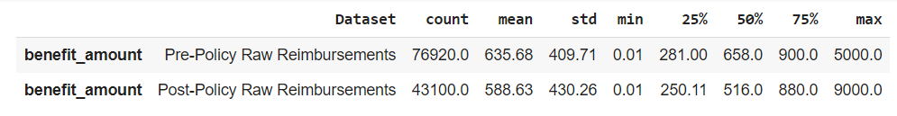
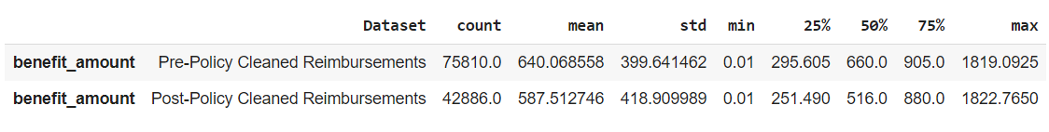
The statistical findings provide insights into the effects of the policy change on the benefit amount of reimbursements (benefit_amount).

In the Pre-Policy Raw Reimbursements dataset, before the policy change, the average benefit amount was $635.68, with a high variability indicated by a standard deviation of $409.71. After the policy change, in the Post-Policy Raw Reimbursements dataset, the average benefit amount decreased slightly to $588.63, and the variability decreased as well, as shown by the lower standard deviation of $430.26.

Similarly, in the Pre-Policy Cleaned Reimbursements dataset, before the policy change, the average benefit amount was $640.07, with a standard deviation of $399.64. After the policy change, in the Post-Policy Cleaned Reimbursements dataset, the average benefit amount decreased slightly to $587.51, and the variability decreased with a lower standard deviation of $418.91.

From these findings, we can infer that the policy change has had an impact on the benefit amounts of reimbursements. In both the raw and cleaned datasets, there is a decrease in the variability of benefit amounts after the policy change. This suggests that the policy change may have led to more consistent benefit amounts in the reimbursements data, as indicated by the decrease in the standard deviation.

However, these findings are based on the analysis of the benefit_amount feature alone and may not capture the full impact of the policy change on other aspects of the reimbursements data. Further analysis and consideration of additional factors would be necessary to fully understand the effects of the policy change on reimbursements variability.

